* 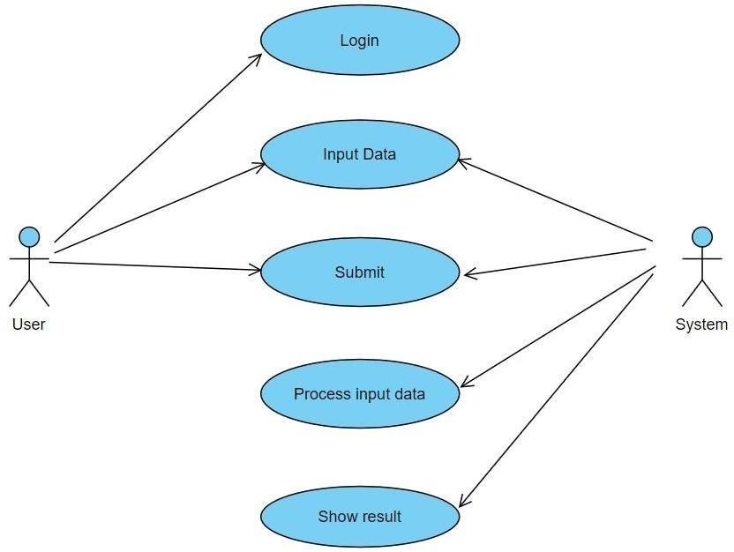**USE CASE DIAGRAM :**
* **CLASS DIAGRAM :**

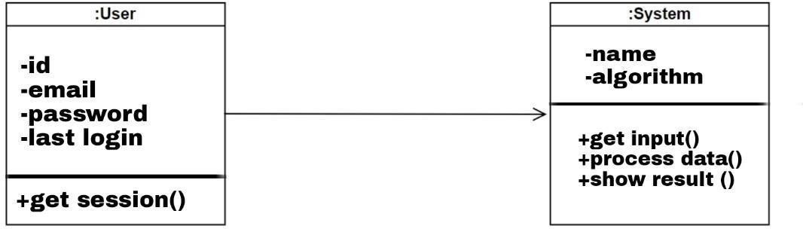

* **SEQUENCE DIAGRAM :**

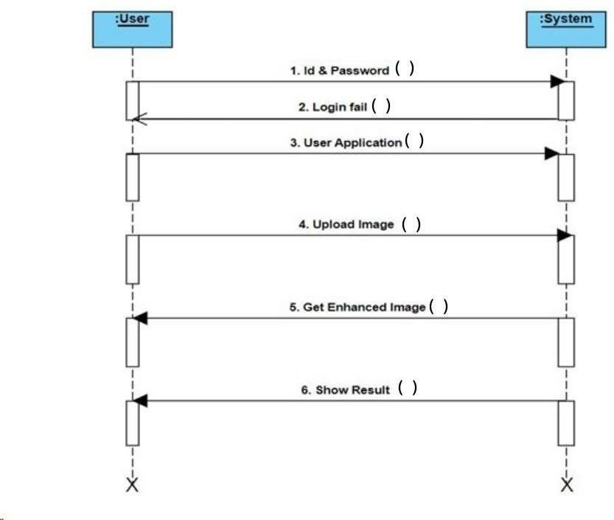

* **ACTIVITY DIAGRAM :**

